1. **Perform Sharpening of Image using Gradient masking**

**Aim:**

To perform sharpening of image using gradient sharpening using python.

**Code:**

import cv2

import numpy as np

image = cv2.imread(r"C:\\Users\\prith\\Documents\\CV\\cvimage.jpg", cv2.IMREAD_COLOR)

if image is None:

print("Error: Could not load the image. Check the file path.")

exit()

gray_image = cv2.cvtColor(image, cv2.COLOR_BGR2GRAY)

sobel_x = cv2.Sobel(gray_image, cv2.CV_64F, 1, 0, ksize=3)

sobel_y = cv2.Sobel(gray_image, cv2.CV_64F, 0, 1, ksize=3)

gradient_magnitude = cv2.magnitude(sobel_x, sobel_y)

gradient_magnitude = cv2.convertScaleAbs(gradient_magnitude)

alpha = 1

beta = 0.5

sharpened_image = cv2.addWeighted(gray_image, alpha, gradient_magnitude, beta, 0)

cv2.imshow("Original Image", gray_image)

cv2.imshow("Gradient Magnitude (Mask)", gradient_magnitude)

cv2.imshow("Sharpened Image", sharpened_image)

cv2.waitKey(0)

cv2.destroyAllWindows()

**Input:**

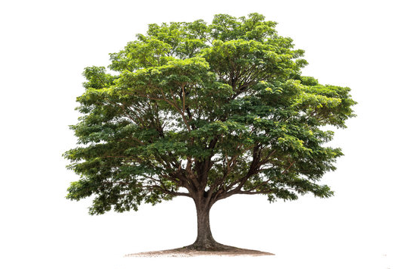

**Output:**

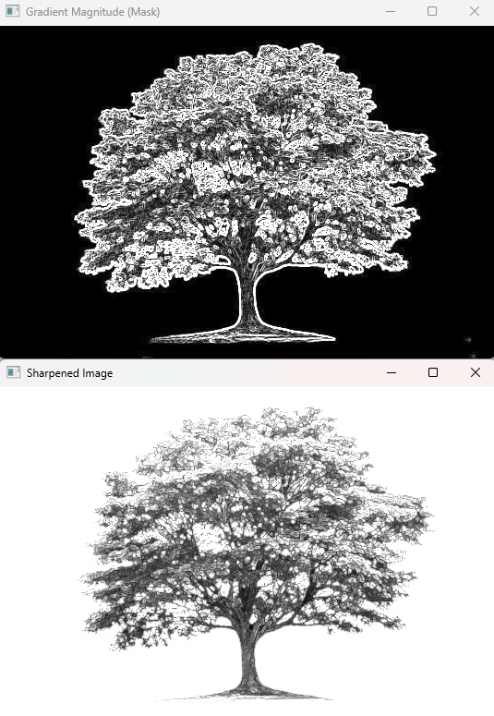

**Result:**

The python code to perform Sharpening of Image using gradient masking has been executed successfully.